CHAPTER 35
INTERFERENCE
Discussion Questions
Q35.1 Being in water reduces the wavelength. This causes the interference maxima to be more closely spaced (Eq.35.6).

Q35.2 Longitudinal waves obey the principle of superposition and interfere so a two-source interference experiment can be done with sound waves. The sources must be coherent, such as two loudspeakers driven by the same amplifier. The wavelength for sound waves is much larger than for visible light so if 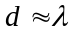 then the two sources would be farther apart in the sound experiment. Reflection of the sound waves would need to be suppressed.

Q35.3 When is small, 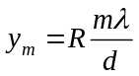 and the distance on the screen between adjacent bright fringes is 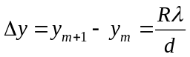. 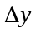 doesn’t depend on m, so adjacent fringes are equally spaced near the center of the screen, where is small. For any angle, 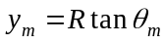 and 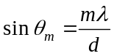. is derived by setting 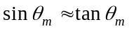, valid for small 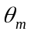. For larger angles, 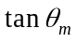 is increasingly larger than 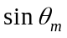 and adjacent fringes get farther and farther apart as the distance from the center of the screen increases.

Q35.4 For small angles, bright fringes are located by 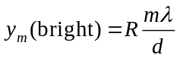 and the distance between adjacent bright fringes is 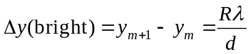. For small angles, dark fringes are located by 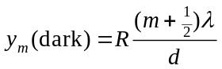. The distance on the screen between a bright fringe and an adjacent dark fringe is 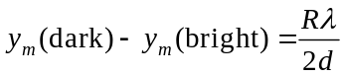. Near the center of the screen, where the small angle approximation is valid, the bright fringes are midway between the dark fringes. This is no longer true away from the center of the screen, where the small angle approximation is no longer valid. Then a bright fringe is not midway between dark fringes but instead is somewhat closer to the adjacent dark fringe of smaller m.

Q35.5 No, they will not produce an interference pattern. They are not coherent sources.

Q35.6 The location of points of constructive and destructive interference depend only on the wavelength of the wave and the distance between the two sources so the positions of the nodal and antinodal lines would be unaffected. There would be total reinforcement at points on the antinodal curves but there would not be total cancelation at points on the nodal curves.

Q35.7 In principle, yes. But the wavelengths of gamma rays is 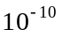 m or less. The two slits, or coherent sources, would have to be about m apart. This is about the size of atoms and would be very difficult to achieve.

Q35.8 Red light has a wavelength of about 700 nm. For two slits separated by 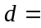 25 cm, 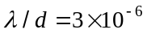. The angular positions of adjacent maxima and minima would be very close together and the pattern of light and dark fringes would not be observable.

Q35.9 The first dark fringe on one side of the central bright fringe is located at 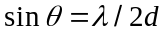. If this fringe is at 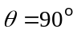 it isn’t observed. This gives 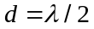. If 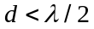 the central bright fringe is spread over the entire screen and no dark fringes are observed.

Q35.10 The phase angle does indeed have these values at points on the screen where there is totally constructive interference. But at all other points on the screen has values differing from these.

Q35.11 Yes, there would be overlapping interference patterns, for each wavelength of the light. The pattern would have a rainbow appearance. There would be bright fringes of each color but no dark fringes because at each point on the screen there will be constructive interference for some wavelength.

Q35.12 No, amplitudes must be added. For electromagnetic waves, for example, it is the electric and magnetic fields that obey the principle of superposition. Intensities are always positive and don’t interfere.

Q35.13 The water can act as a non-reflecting coating, as described in Example 35.7.

Q35.14 For a soap film with air on either side of the film, there is a half-cycle phase shift when light is reflected off the top of the film but no phase shift due to reflection when it reflects off the bottom surface. The net phase difference due to the reflections is a half-cycle phase difference. So when the film is very thin and there is no additional phase difference introduced by the path difference, the light reflected from the top and bottom of the film interferes destructively. For a soap film on glass rays reflected at both the top and bottom surfaces of the film have a half-cycle shift upon reflection so there is no net phase difference due to the reflection. Then for a very thin film the two light rays reflected from the top and bottom of the film are in phase and interfere constructively.
Q35.15 For visible light reflecting from a thick film, the values of m in Eq.(35.17) will be large and the wavelength change for successive values of m will be very small. Closely spaced wavelengths will have constructive interference and no one wavelength appears to be emphasized more than any other in the reflected light. The interference still occurs but its effects are unobservable. A film might be considered thick if it is more than 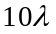 thick.

Q35.16 Conservation of energy requires that light of a given wavelength either be reflected or transmitted. The reflected and transmitted intensities must add up to the incident intensity. So, if the light isn’t reflected due to interference then it must be transmitted.

Q35.17 If the intensity of the reflected light is small then the intensity of the light transmitted through the film is large. See Q35.16.

Q35.18 At a very thin part of the film the path difference due to the thickness of the film introduces negligible phase difference. To get destructive interference then there must be a net half-cycle phase difference due to the reflections. When light in air reflects from the top surface of the oil film there is a half-cycle phase shift since 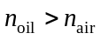. So there must be no phase shift when the light traveling in oil reflects off the interface between oil and water at the bottom surface of the film. This will be the case if and only if 

